NAME: PUNEETH RAJ M R 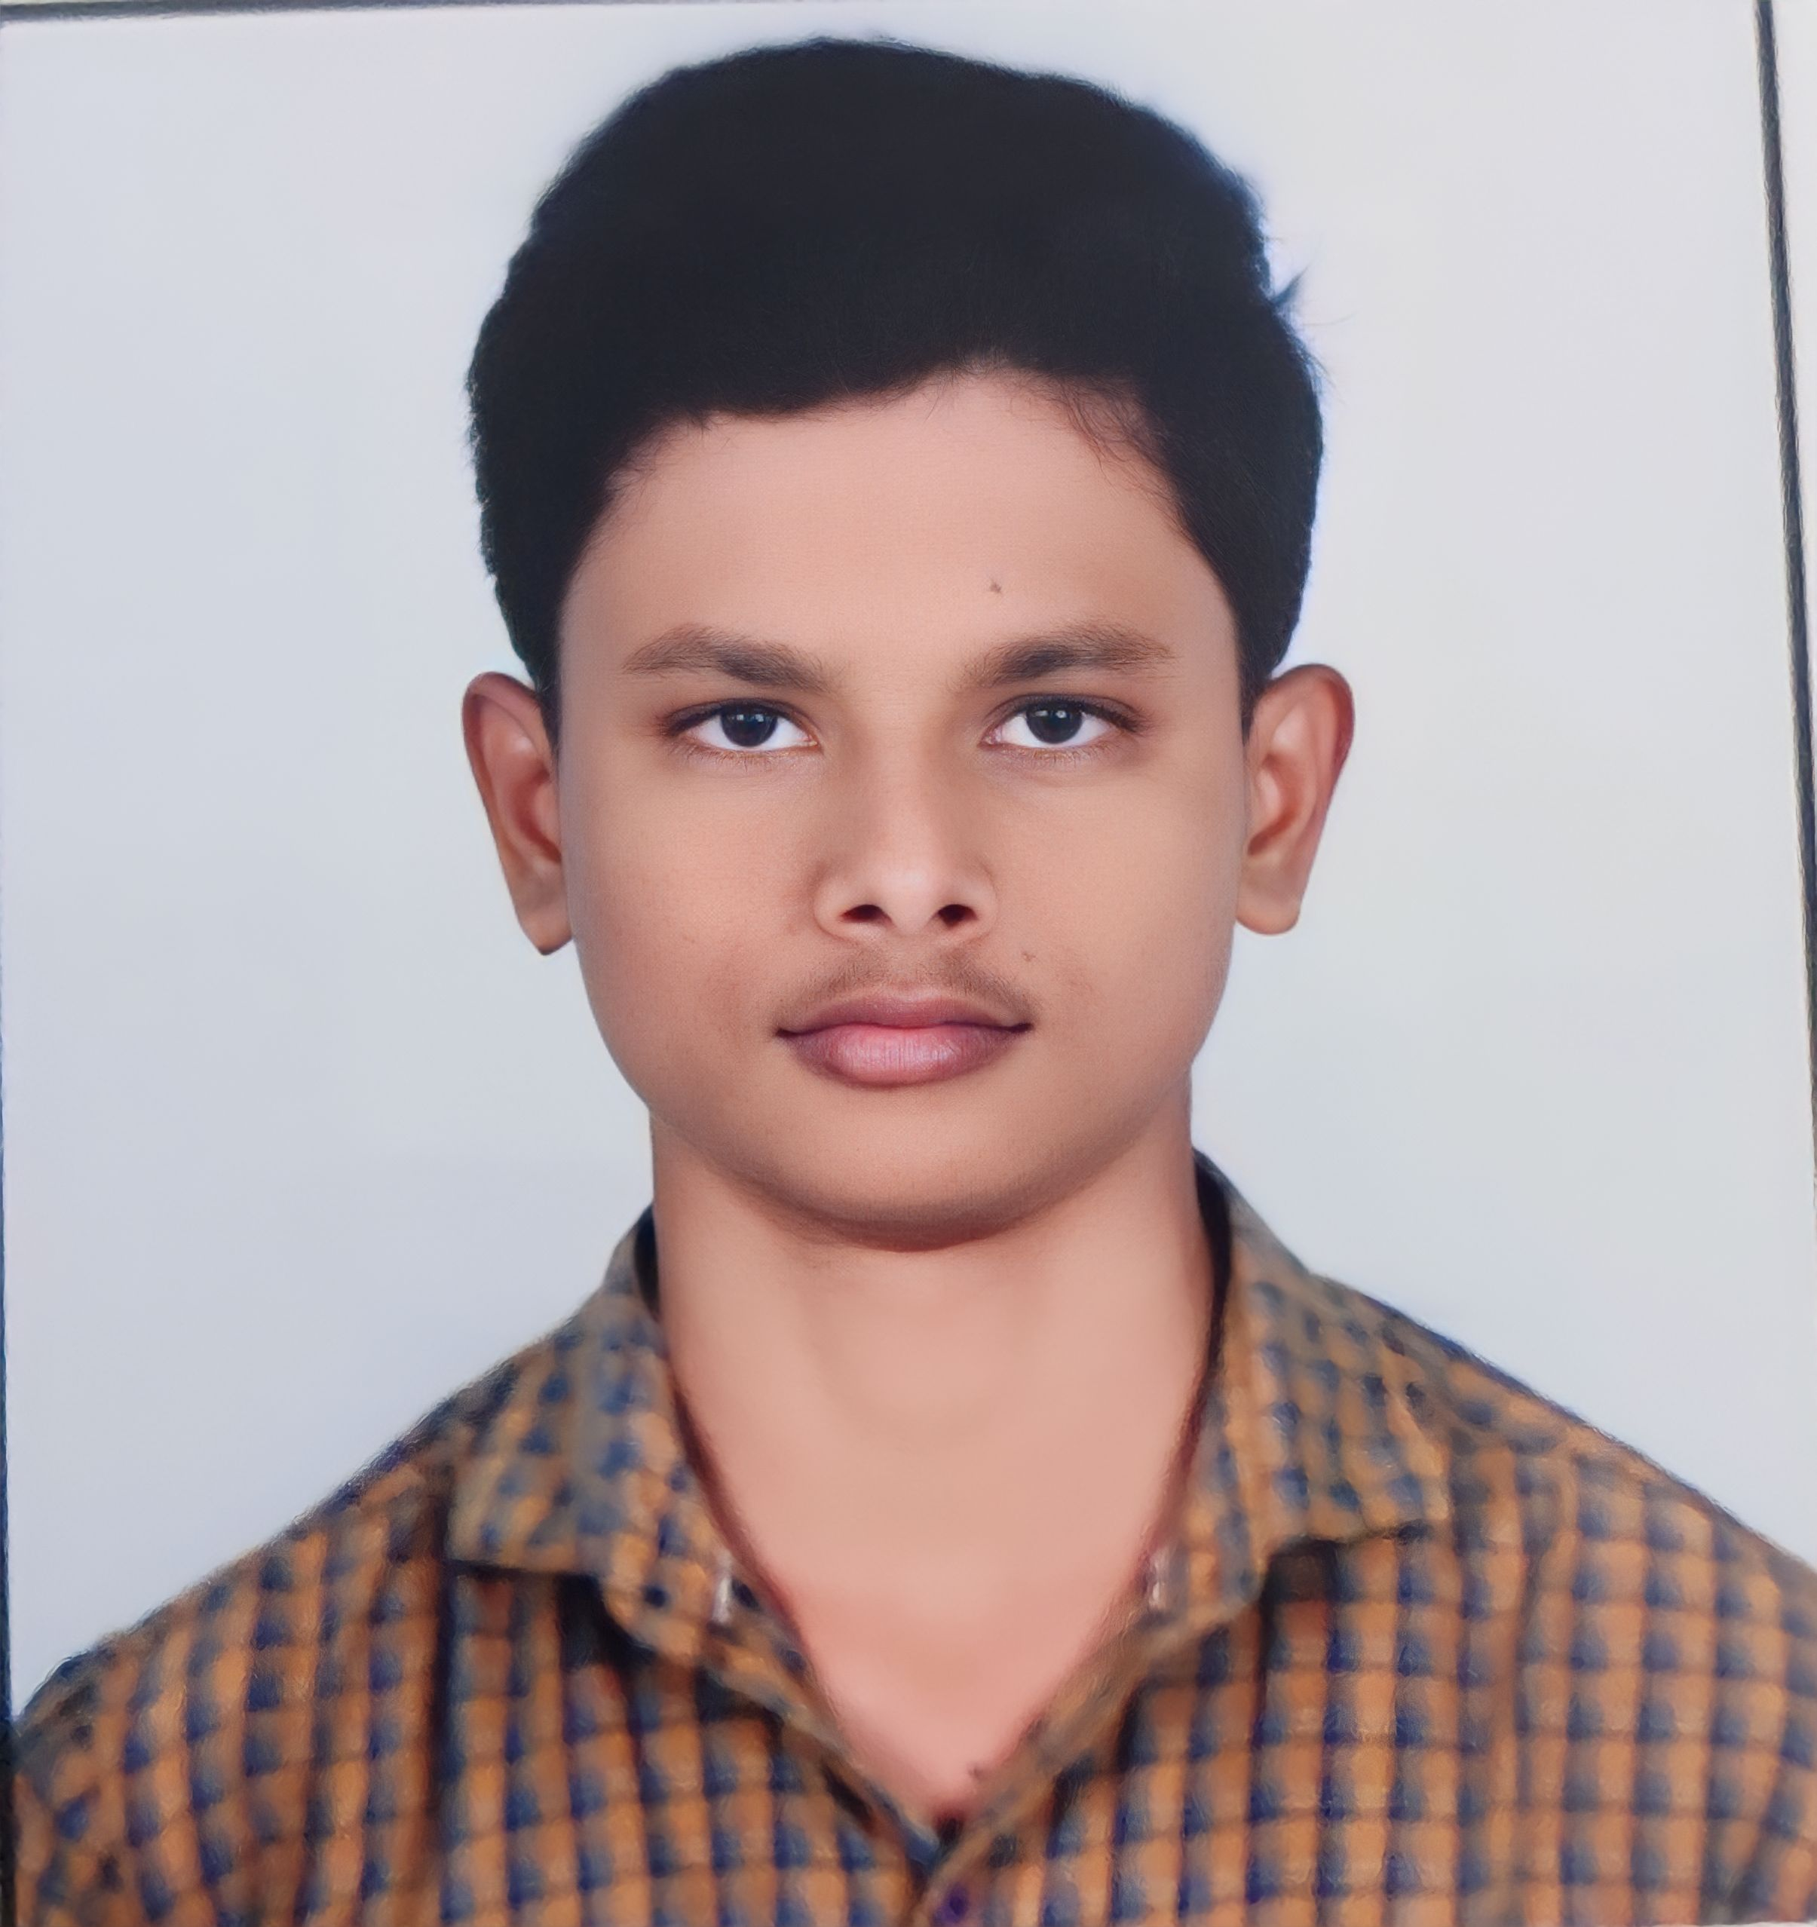
ADDRESS: MANDYA, KARNATAKA
EMAIL: puneethraj123890@gmail.com
MOBILE: 7019605502

CAREER OBJECTIVE
I Want to be a cyber security analyst and a certified ethical hacker and I wan to gain more knowledge about Robotics & AI & about ongoing technology. I wan to become a professional programmer and developer. I like to develop a perfect AI Robot.

EDUCATION
QUALIFICATION | INSTITUTE | YEAR OF PASSING | STREM | PERCENTAGE
SCHOOL | ADARSHA VIDYALAYA(RMSA) | 2019 |  | 89%
COLLEGE | ARADHANA COLLEGE | 2021 | PCMB | 93%
ENGINEERING | NAGARJUNA COLLEGE OF ENEGINEERING | 2025 | COMPUTER SCIENCE | 9 CGPA

TECHNICAL SKILLS:
- C
- C++
- HTML
- CSS
- JAVA SCRIPT
- JAVA
- PYTHON
- ETHICAL HACKING & NETWORKING
- CYBER SECURITY & O S
- ROBOTICS
- BLOCK CHAIN
- PHP
- NUCLEAR SCIENCE
- A I
- RADAR TECHNOLOGY
- BIO FUEL MECHANICS
PROJECTS:
- ROBOTIC HAND MODEL (GOT PRIZE ON SRISTHI HACKTHON)
- HOME AUTOMATION
- AUTO PILOT MODE USING ULTRASONIC SENSOR
- MOON ROVER
- HYBRID VEHICALS
- SOLUTION FOR ICE MELTING ON ROAD (GOT PRIZE ON EXHIBITION)
- WEBSITE DEVELOPED FOR COLLEGE
- BOLCK CHAIN PROJECT ON LAND RECORDS
INTERENSHIP TRAINING COURSES:
- ORGANIZATION:DEFENCE RESERCH DEVELOPMENT ORGANIZATION
(APPROVED WAITING FOR LETTER)
TITLE:CRYPTO MINING
DESCRIPTION: I WILL LEARN ABOUT CRYPTONIUM AND RADAR TECHNOLOGY

- ORGANIZATION:INDIAN INSTITUTE OF SCIENCE
(APPROVED WAITING FOR LETTER)
TITLE:CYBER SECURITY
DESCRIPTION: I WILL LEARN ABOUT ETHICAL HACKING

- ORGANIZATION:NAGARJUNA COLLEGE OF ENGINEERING
TITLE:PROGRAMMING SKILLS
DESCRIPTION: I LEARNED PROGRAMMING LANGUAGES

EXTRA CIRICULAR ACTIVITES
- DISTRICT LEVEL BADMINTON PLAYER
- TALUK LEVEL KABADDI PLAYER
- GOOD IN PLAYING ROLE IN DRAMA
- ATHLETICS
HOBBIES
- LEARIMG ABOUT NEW TECHNOLOGY
- BADMINTON & ATHLETICS
- E SPORTS
- KABBADI
- HACKING & WEB DEVELOPING

PERSONAL DETAILS:
DOB: 19-05-2004
FATHER NAME: RAMESH
MOTHER NAME: S MANJULA
LANGUAGE KNOWN:
- KANNADA
- HINDI
- ENGLISH
NATIONALITY: INDIAN
MATRIAL STATUS: NO
PERMANENT ADRESS:
MALAVALLI , MANDYA(DIST) , KARNATAKA.

DECLARATION:
I hereby declare that above mentioned information is correct up to my knowledge and I bear the responsibility for the correctness of the above mentioned particulars.

Place: Bengaluru PUNEETH RAJ M R
Date: 7-12-2022

